2023 -24 HOUSEHOLD APPLICATION FOR FREE AND REDUCED-PRICE
MEALS Lopez Island School District
86 School Rd
Lopez Island WA 98261
Complete, sign, and return this application to: 86 School Rd. Lopez Island WA 98261
Check here if you received meal benefits last year: Homeless Migrant
- List all students living with you that are attending school. If the student is a foster child, homeless, or migrant, indicate this by placing an “x” in the appropriate box. Include any personal income received by the student and make an “x” in the correct box for how often it is received.
Student’s Last Name | Student’s First Name | MI | Foster | Date of Birth | School | Grade |  | Student Income | Weekly | Bi  -  weekly | X Month  2 | Monthly
 |  |  |  |  |  |  | $
 |  |  |  |  |  |  | $
 |  |  |  |  |  |  | $
 |  |  |  |  |  |  | $
 |  |  |  |  |  |  | $
________________________________________________________ | _______________________________________ | __________________ | _____________________
Mailing Address | City, State & Zip Code | Daytime Phone | Date
OSPI CNS | Page 1 of 2 |  | April 2023
- If any Household Members (including yourself) currently participate in one or more of the following assistance programs, please write in a case number. If no, go to Step 3.
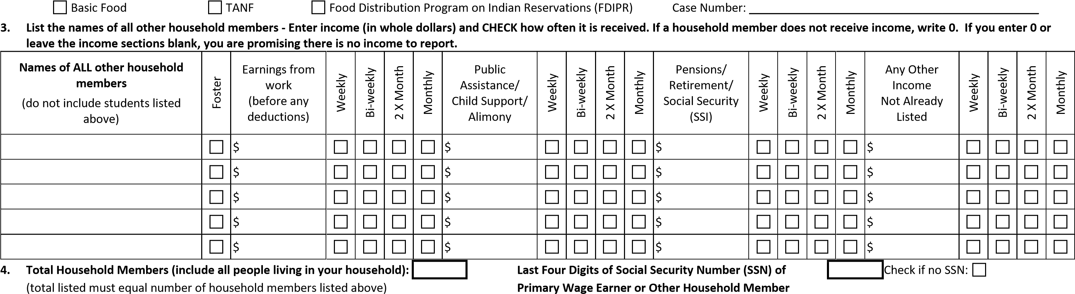
- Contact Information & Signature – Complete, sign, and return this application to: Laurie Jardine
I certify (promise) that all information on this application is true and that all income is reported. I understand that this information is given in connection with the receipt of federal funds and that school officials may verify (check) the information. I am aware that if I purposely give false information, my children may lose meal benefits, and I may be prosecuted under applicable State and Federal laws.
_______________________________________________ _________________________________________________ __________________________________________
Printed Name of Adult Household Member Adult Household Member Signature E-mail Address
- Children’s Racial and Ethnic Identities (Optional) – We are required to ask for information about your child(ren)’s race and ethnicity. This information is important and helps make sure we are fully serving our community. Responding to this section is optional and does not affect your child(ren)’s eligibility for free & reduced-price meals.
Mark one or more racial identities: American Indian or Alaska Native Asian Mark one ethnic identity:
Black, or African American Native Hawaiian or Other Pacific Islander Hispanic or Latino
White Not Hispanic or Latino
The Richard B. Russell National School Lunch Act requires the information on this application. You do not have to give the information, but if you do not, we cannot approve your child for free or reduced price meals. You must include the last four digits of the social security number of the adult household member who signs the application. The last four digits of the social security number is not required when you apply on behalf of a foster child or you list a Supplemental Nutrition Assistance Program (Basic Food), Temporary Assistance for Needy Families (TANF) Program or Food Distribution Program on Indian Reservations (FDPIR) case number or other FDPIR identifier for your child or when you indicate that the adult household member signing the application does not have a social security number. We will use your information to determine if your child is eligible for free or reduced-price meals, and for administration and enforcement of the lunch and breakfast programs. We MAY share your eligibility information with education, health, and nutrition programs to help them evaluate, fund, or determine benefits for their programs, auditors for program reviews, and law enforcement officials to help them look into violations of program rules.
In accordance with federal civil rights law and U.S. Department of Agriculture (USDA) civil rights regulations and policies, this institution is prohibited from discriminating on the basis of race, color, national origin, sex (including gender identity and sexual orientation), disability, age, or reprisal or retaliation for prior civil rights activity.
Program information may be made available in languages other than English. Persons with disabilities who require alternative means of communication to obtain program information (e.g. Braille, large
print, audiotape, American Sign Language, etc.), should contact the responsible state or local agency that administers the program where or USDA's TARGET Center at (202) 720-2600 (voice and TTY) or contact USDA through the Federal Relay Service at (800) 87708339.
To file a program discrimination complaint, a Complainant should complete a Form AD-3027, USDA Program Discrimination Complaint Form which can be obtained online at: https://www.usda.gov/sites/ default/files/documents/USDA-OASCR%20P-Complaint-Form-0508-0002-508-11-28-17Fax2Mail.pdf from any USDA office, by calling (866) 632-9992 , or by writing a letter addressed to USDA. The letter must contain the complainant's name, address, telephone number, and a written description of the alleged discriminatory action in sufficient detail to inform the Assistant Secretary for Civil Rights (ASCR) about the nature and date of an alleged civil rights violation. The completed AD-3027 form or letter must be submitted to USDA by mail: U.S. Department of Agriculture, Office of the Assistant Secretary for Civil Rights, 1400 Independence Avenue, SW, Washington, D.C. 20250-9410; or fax: (833) 256-1665 or (202) 690-7442; or email:program.intake@usda.gov.
This institution is an equal opportunity provider.
Lopez Island School District’s Non-Discrimination Statement
The Lopez Island School District does not discriminate in any programs or activities on the basis of sex, race, creed, religion, color, national origin, age, veteran or military status, sexual orientation, gender expression or identity, disability, or the use of a trained dog guide or service animal and provides equal access to the Boy Scouts and other designated youth groups. The following employee(s) has been designated to handle questions and complaints of alleged discrimination: Civil Rights Compliance Coordinator, Ed Murray – emurray@lopezislandschool.org; Title IX Coordinator, HR Specialist, Beth Stanford– bstanford@lopezislandschool.org; Section 504, Mary Fordham – mfordham@lopezislandschool.org; OR contact by phone, 360-468-2202, OR mail to 86 School Rd, Lopez Island, WA 98261.

SCHOOL USE ONLY – DO NOT WRITE BELOW THIS LINE
ANNUAL INCOME CONVERSION: Weekly x 52; Bi-Weekly x 26; Twice per month x 24; Monthly x 12. | (Do NOT convert to annual income unless household reports multiple pay frequencies).
LEA APPROVAL: Basic Food/TANF/FDPIR/Foster Total Household Size Weekly Bi-Weekly 2x per Month Monthly Annual Income Household Total Household Income $
APPLICATION APPROVED FOR: Free Meals APPLICATION DENIED BECAUSE: Income Over Allowed Amount Other: _________________________
Reduced-Price Meals Incomplete/Missing Information
__________________________ | ___________________________________________________ | ________________________
Date Notice Sent | Signature of Approving Official | Date
OSPI CNS | Page 2 of 2 |  | August 2023

